Dear Partners and Stakeholders,
It’s that time of year again to send a reminder or introduce this data contribution opportunity to the LANDFIRE program. LANDFIRE (LF) is an interagency vegetation, fire, and fuel characteristics mapping program sponsored by the United States Department of Agriculture Forest Service (USFS) and the Department of the Interior (DOI) (https://landfire.gov/). To ensure LF products are current to support landscape assessment, analysis, and management decisions, LF relies heavily on data contributions.

Data Submission Deadline November 30, 2021:
LF will continue to ask for data to be submitted earlier than in the past to help facilitate the production of annually updated products with a goal of data release before June of each year. This transition may take a few years to reach but LF is working towards this goal.
The focus of this data call is to collect FY 2021 disturbance and treatment activities. To make annual updates possible we will be asking for data from the fiscal year which runs from 10/1/2020 – 9/30/2021. Please make every effort to submit your FY 2021 data by November 30, as LF relies heavily on user contributed data for updates. Data submitted after the deadline will be used if schedules allow or will be archived for future use. Data from 2017-2020 that were not previously submitted to LF or other National Authoritative databases, are also welcome. All data contributions must meet LF Requirements. For more information visit https://www.landfire.gov/participate_refdata.php. Data submissions and questions can be sent to Brenda Lundberg, LANDFIRE Reference Data Administrator, blundberg@contractor.usgs.gov

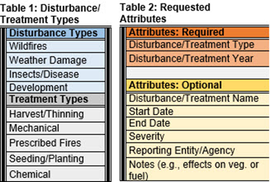
LANDFIRE Data Needs:
- Primary focus - Polygon Disturbance and Treatment Activities that occurred in FY 2021
LF uses recent disturbance and treatment data to help attribute a disturbance cause to image-based change detections and update map layers in areas where vegetation and fuel have changed, keeping the data as current as possible. Examples of these types of data are listed in Table 1. Requested attributes (required and optional) are listed in Table 2. For more information visit: https://www.landfire.gov/participate_contribute.php.
- Secondary focus – Vegetation/Fuel Plot Data and Invasive Plant Species(polygon/plots)
LF relies on plot data for training sites for mapping. For more information visit https://www.landfire.gov/participate_plot.php. LF would also benefit from post-disturbance plot data and polygon or point data on invasive plant species.
LF welcomes feedback information on current products. Submit feedback through the LF helpdesk at https://www.landfire.gov/contactus.php. Additional information about submitting feedback can be found at https://landfire.gov/participate_feedback.php.

Data Contributions and Thanks:
LF acquires data from websites and agency data base systems. For a list of these sources, see the “Website Agency DB” spreadsheet at https://www.landfire.gov/participate_refdata_sub.php.
For a list of past data contributions and to ensure your data have been received and incorporated in the database, see the “Compiled Data” spreadsheet at https://www.landfire.gov/participate_refdata_sub.php. Locally provided landscape data does impact LF and evidence is available for review at https://www.landfire.gov/lf_impacts.php.
LF thanks those who have contributed data in the past and is again asking for your help to enhance and improve LF products through your contributions.

